**PROGRESSIVE EDUCATION SOCIETY’S**

**MODERN COLLEGE OF ARTS, SCIENCE AND COMMERCE,**

**(AUTONOMOUS) GANESHKHIND, PUNE-16**



**ACADEMIC YEAR 2023-2024**

**A**

**PROJECT REPORT ON**

**“Computer Laboratory Management System”**

**SUBMITTED TO SAVITRIBAI PHULE PUNE UNIVERSITY**

**BY**

**ANIRUDDHA ANIL LAGAD (233432149)**

**SACHITANAND RAMKRUSHNA GHULE (233432135)**

**P.E. Society’s**

**Modern College of Arts, Science & Commerce, (Autonomous) Ganeshkhind, Pune-16**

**Department of BCA (Science)**

**T.Y. B.C.A. (Science)**



**CERTIFICATE**

This is to certify that Project entitled “**Computer Laboratory Management System”** was completed by **Aniruddha Anil Lagad (233432149), Sachitanand Ramkrushna Ghule (233432135)**. As requirement of T.Y.B.C.A (Science) Examination for the academic year 2023-2024 for Savitribai Phule Pune University.

**Miss. Rutuja Mokashi Dr. Deepak Kumbhar**

**(Project Guide) (Head of Department )**

**Internal Examiner External Examiner**

**Acknowledgement**

The completion of any endeavor is not merely a solitary accomplishment, but a collective achievement fueled by the collaborative efforts and unwavering support of numerous individuals.

We sincerely thank Dr. Deepak Kumbhar for the confidence reposed in us.

We are also indebted to Miss. Rutuja Mokashi for her valuable assistance and expertise, which have greatly contributed to the success of our endeavor. Her dedication and expertise have been indispensable throughout the project's development.

Furthermore, we would like to extend our thanks to our colleagues and peers whose collaborative spirit and support have been a constant source of inspiration. Their willingness to share knowledge and lend a helping hand have been essential in overcoming challenges and achieving our goals.

**INDEX**

|  |  |  |
| --- | --- | --- |
| Sr.no | Topic | Page no. |
| 1 | Introduction | 1 |
| 2 | Requirement Specification | 2 |
| 3 | Diagrams |  |
|  | 1. ER Diagram | 3 |
|  | 1. Data Flow Diagram | 4 |
| 4 | Input Output Screens | 5, 6 |
| 5 | Testing | 7 |
| 6 | Limitations | 8 |
| 7 | Future Enhancement | 9 |
| 8 | Conclusion | 10 |
| 9 | Bibliography | 11 |

**Introduction**

In the realm of educational institutions, the effective management of computer laboratories plays a pivotal role in facilitating seamless learning experiences for students and optimizing resources for educators. The Computer Laboratory Management System (CLMS) emerges as a sophisticated solution designed to streamline the operational aspects of computer laboratories within academic settings.

The Computer Laboratory Management System (CLMS) is a sophisticated solution tailored for educational institutions to streamline the management of computer laboratories. Offering a range of functionalities, CLMS enables users to check practical schedules, lab availability, practical exam schedules, and track lab assignments.

Additionally, it provides real-time information on lab occupancy, facilitates the download of lab materials, and ensures efficient utilization of laboratory resources. In essence, CLMS enhances the learning experience by fostering efficiency, transparency, and collaboration within academic environments.

**Requirement Specification**

* **Hardware Requirements:**
* Processor : Intel Core i3/i5 or equivalent
* RAM : 4GB or higher
* Cache : 512KB or more
* Hard Disk : 100GB HDD or higher

OR

* SSD : 10GB SSD or higher
* **Software Requirements:**
* Operating System : Windows 10 or Ubuntu 20.04 LTS or Linux
* Front End Software : Browser (Chrome/Firefox/other)
* Back End Software : PHP 7.4 or higher, XAMPP Control Panel

(Apache, MySQL), PostgreSQL 12.0 or higher

**Diagrams**

**ER-Diagram:**

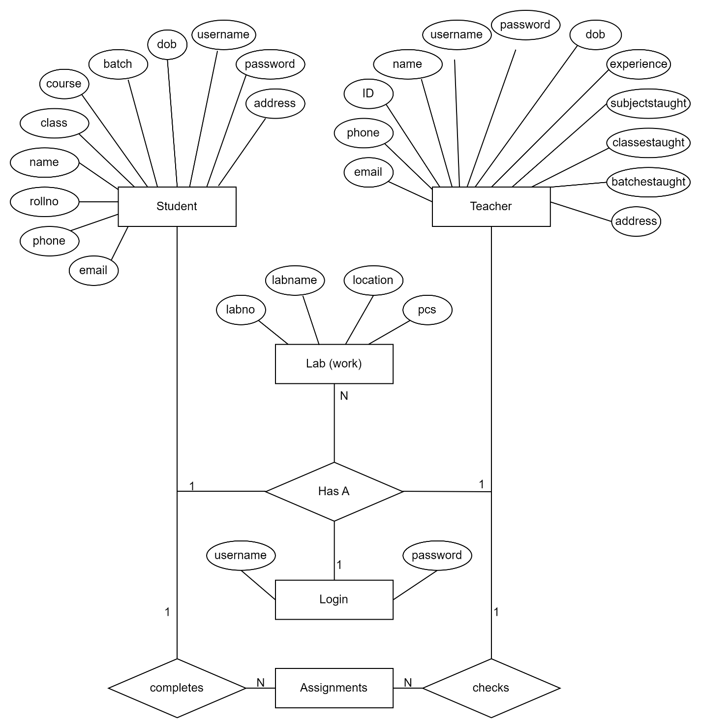

**DFD:**

**Context level:**

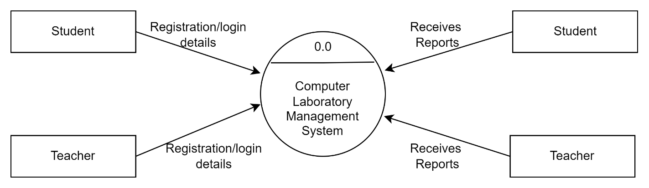

**1st level:**

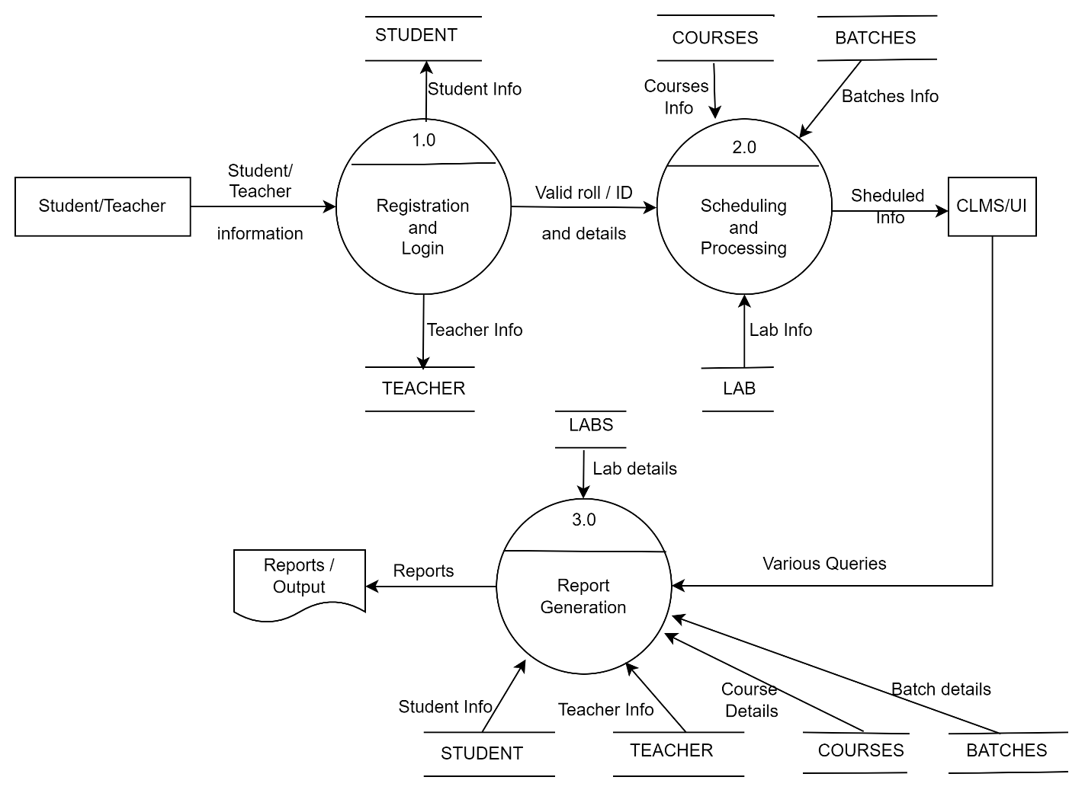

**Input Output Screen**

1. **Index page**

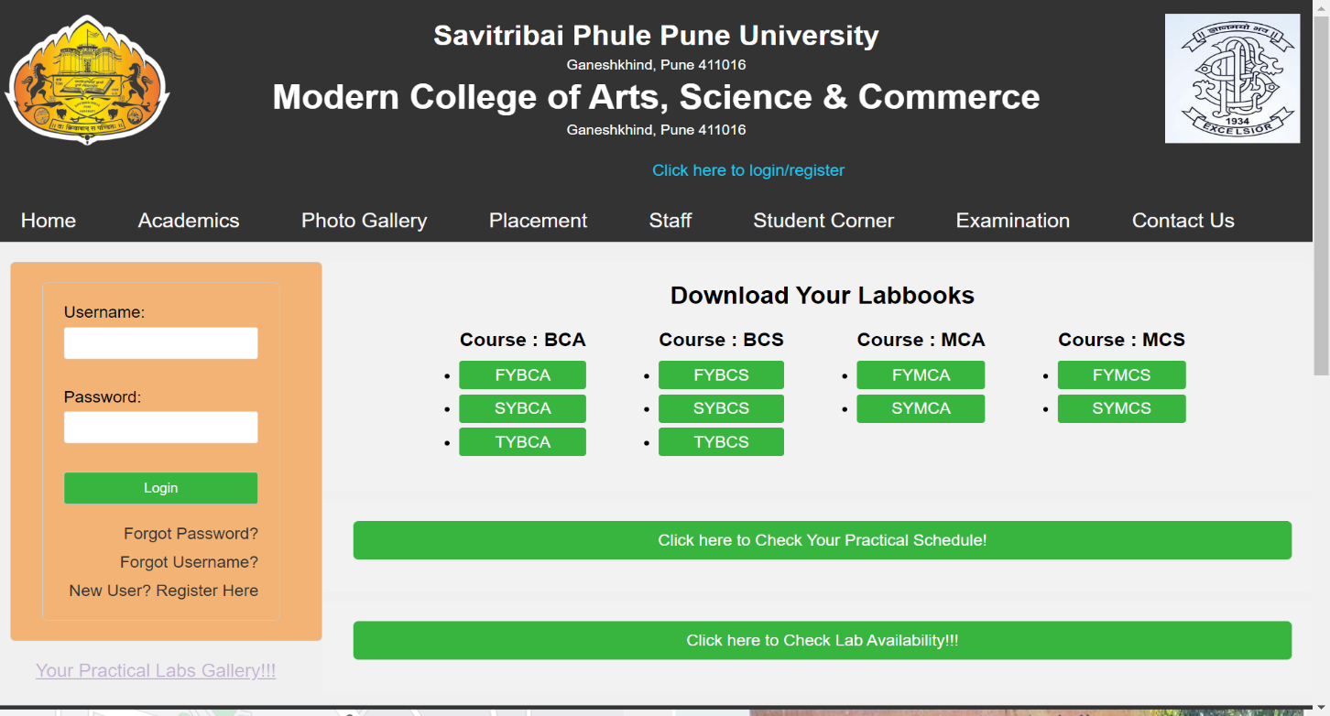

1. **Registration Page**

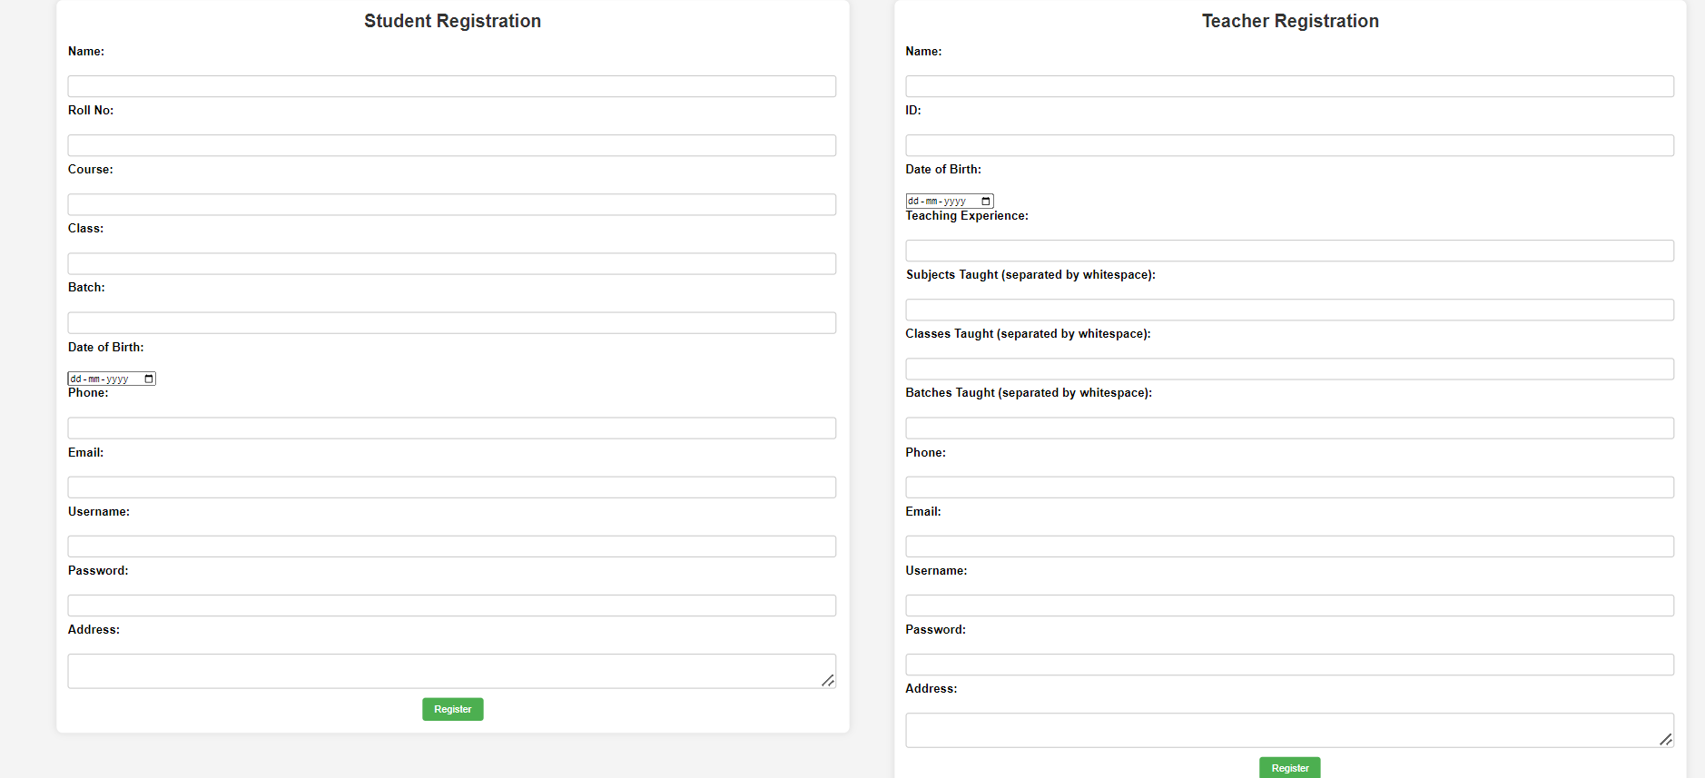

1. **Login Page**

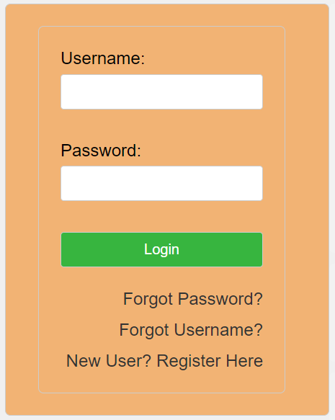

1. **Main UI**

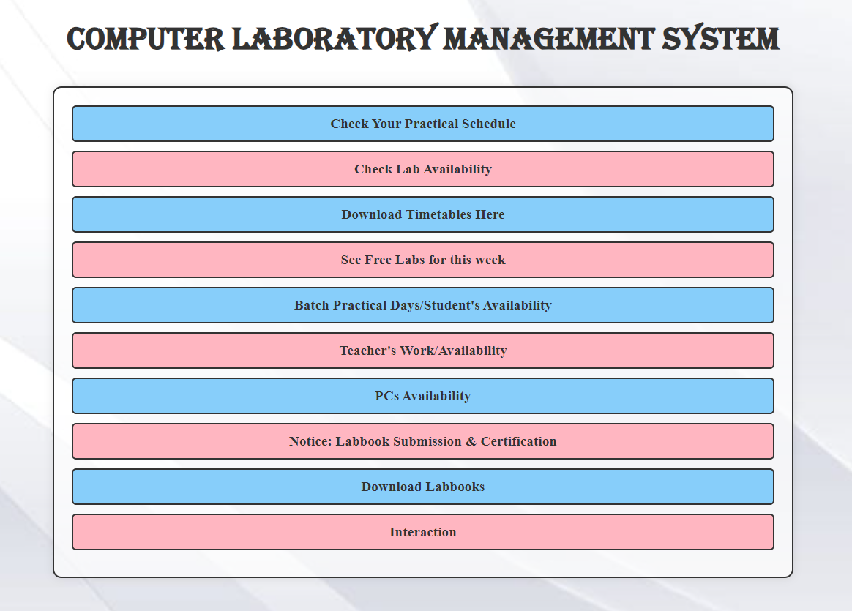

**Testing**

**Table tests for the login page:**

|  |  |  |  |
| --- | --- | --- | --- |
| **Test Case Name** | **Test Case Description** | **Test Data** | **Test Result** |
| Validate Login | To verify login | Enter wrong username & password and click on login button | Message as “Invalid Username & Password” |
| Verify Username | To verify valid email id | Regular expression | Message as “Invalid Username” |
| Verify Password | To verify valid password | Enter alphanumeric character | Message as “Invalid Password” |

**Table tests for the registration page:**

|  |  |  |  |
| --- | --- | --- | --- |
| **Test Case Name** | **Test Case Description** | **Test Data** | **Test Result** |
| Validate Phone  Number | To verify valid phone  Number | Enter wrong phone number or use one phone number for multiple registrations | Message as “Invalid phone number” or  “Already registered with this phone number” |
| Verify Email | To verify valid email id | Enter wrong email or use one email for multiple registrations | Message as “Invalid email” or  “Already registered with this email” |
| Verify Username | To verify valid username | Regular expression or type nothing | Message as “Invalid Username” or “Username is mandatory” |
| Verify Password | To verify valid password | Enter alphanumeric character or type nothing | Message as “Invalid Password” or “Password is mandatory” |
| Verify RollNo / TID | To verify valid RollNO/TID | Enter wrong Roll/Tid or alphanumeric character | Message as “Roll/tid must be integer/numeric value” |

**Limitations**

* Lack of Customization: If the system lacks flexibility or customization options, it may not meet the diverse needs of different educational institutions or fail to adapt to changing requirements over time.
* Incomplete or Inaccurate Data: Inaccurate or incomplete data entry by users can undermine the system's effectiveness and reliability, leading to errors or inconsistencies in scheduling, assignments, or other functionalities.
* Currently the system doesn’t provide high security as it doesn’t have OTP based authentication.

**Future Enhancement**

1. Will send the forgot password & forgot username on the users Email & SMS to avoid insecurity to user account.
2. Also we will provide OTP based authentication service for the security purpose.
3. Will provide more modularity to the project. So that it can be implemented by any institute/college/university with flexibility & robustness.
4. Will take more precautions while registration to avoid incomplete/inaccurate data.
5. Will convert this web application into android application with further more improvements.

**Conclusion**

In conclusion, the Computer Laboratory Management System (CLMS) project represents a significant step forward in optimizing the management and utilization of resources within educational institutions. Through the development and implementation of this system, several key objectives have been achieved, including facilitating efficient scheduling of practical sessions, lab availability etc.

The CLMS project offers a user-friendly interface that streamlines administrative tasks for both students and teachers, enhancing overall productivity and organization. By centralizing information related to laboratory schedules, assignments, and equipment availability, the system promotes transparency and accountability, ultimately contributing to a more effective learning environment.

While the CLMS project has made significant strides in addressing the challenges associated with laboratory management, there is room for further refinement and enhancement. Future iterations of the system could focus on incorporating advanced analytics capabilities, improving scalability, and enhancing security measures to ensure data integrity and confidentiality.

Overall, the CLMS project serves as a valuable tool for educational institutions seeking to optimize resource allocation, improve operational efficiency, and enhance the overall learning experience for students and educators alike. With continued support and investment, the CLMS project has the potential to evolve into a cornerstone of laboratory management in educational settings.

**Bibliography**

**Books:**

* Web Technology SYBCA textbook of Nirali Prakashan
* Software Engineering SYBCA & Software Project Management TYBCA textbook of Nirali Prakashan

**Websites:**

* <https://www.w3schools.com/php/php_mysql_intro.asp>
* <https://www.tutorialspoint.com/postgresql/index.htm>